

National College of Ireland

Date: 3rd of November 2020

BSc (Honours) in Computing

Software Development

Academic Year 2020/2021

Student Name: Daniel Costel Neagu

Student Number: x17128463

Student Email: x17124863@student.ncirl.ie

Farmers Market

Mid-Point Technical Report

Contents

Executive Summary 2

1.0 Introduction 2

1.1. Background 2

1.2. Aims 3

1.3. Technologies 4

1.4. Structure 4

2.0 System 5

2.1. Requirements 5

2.1.1. Functional Requirements 5

2.1.1.1. Use Case Diagram 7

2.1.1.2. Requirement 1: View/Browse Products 8

Description & Priority 8

Use Case 1 8

2.1.1.3 Requirement 2: Register User 10

Description & Priority 10

Use Case 2 10

2.1.1.4 Requirement 3: Login 11

Description & Priority 11

Use Case 3 11

2.2. Graphical User Interface (GUI) 14

3.0 Appendices 18

3.1 Project Proposal 18

1.0 Objectives 20

2.0 Background 20

3.0 Technical Approach 21

4.0 Special Resources Required 22

5.0 Project Plan 22

6.0 Gantt Chart 23

7.0 Technical Details 24

8.0 Evaluation 25

9.0 References 25

# Executive Summary

This report exhibits my ideas on how I will design and develop an E-Commerce web site having as its activity oriented around Farmers Market model.

The customers will be able to browse and view the available merchandise for sale that is going to be uploaded by the farmers and producers. To make sure that the goods on sale are real, they will be revised and approved by one of the admins. The shoppers can make the purchase of goods as soon they login into the system of course after they register with us. For the farmers and producers to be able to access our system first they will be screened to make sure that they are part of the local community, then they will be given a trader account where they can upload their products to be able to advertise and sale them.

This project is trying to move the conventional brick and mortar model of buying and selling of goods and produce found in a Farmers Market and bring them online in the Cloud by using modern methods and technologies. By doing so I will give access for more people to this market and not only that, but I will restart a very affected sector of the economy at this time by opening an online version of commerce.

# Introduction

The purpose of this document is to give an overview on the technical details and documentation necessary for me to successfully deploy a state-of-the-art E-Commerce web site deployed on Microsoft Azure Cloud that is providing a new way to facilitate de trading of local grown and outsourced produces and goods.

## Background

I undertook the development of this project as I was directly affected at the begging of this year by the closure of my local Farmers Market, due to current measures put in place by the government to stop of the spread of the Covi-19 virus pandemic. One of this hardship was by not being able to physically to visit and purchase anymore my favourite local sourced products from the Framers Market. Another factor that contributed to my decision to start developing a new alternative to this disrupted market was the fact that I was recently relocated with my accommodation and work, and going to one of this local Farmers Markets in person was out of my reach as I wasn’t within the allowed travelling limits anymore imposed by the authorities thru the year.

As I wanted to access and have all my necessary and favourite artisan foods, cheeses, meats, organic vegetables and fruits I went online, and I searched to find a way to purchase them again. The online search didn’t return any relevant information regarding any place from where to get them directly or indirectly from. Reflecting at this current situation I got the idea on how to fix this problem, by developing my E-Commerce web site I will bring back the local community to buy and sale locally again at a larger scale and in a much safer way, from the reach of a click.

## Aims

By developing this project, I will create a new online platform where it will facilitate the trade of local goods and where the local people can purchase again their favourite fresh and in-season products as they did once in their local Farmers Markets, but this time online by creating an account with us giving them the safety by not exposing them to the risk of contracting the virus from other people next to them in the market crowd.

This new E-Commerce web site it will make available to his customers a large variety of fresh and in-season produce and with artisan products that are worked and grown locally as they are offered by the local farmers and producers that are the most affected by these strange times that we all are living in.

The Farmers Market E-Commerce web site it will be available to be accessed online via a multitude of web browsers and network attacked devices like phones, PCs and so on.

By providing to the local Farmers this new E-Commerce Platform, I will enable them to advertise and sale their products as an alternative to this disrupted market by the current Global Pandemic.

## Technologies

To be able to achieve what I set out to do upon the completion of my web site, I will need to make use of my personal laptop that is running Windows 10, where a copy of my progress is going to be kept locally on a separate partition on the disk drive and a backup folder is going to be uploaded in my GitHub account.

Development

Visual Studio Code is a free code editor made by Microsoft and I will be using it to edit my code for my web site.

Popular coding languages and libraries used for this project are HTML5 to display the web site, CSS for styling of the web site, JavaScript and Node.js to enable interaction on the web site, JAVA for the back end server, JSON and React libraries for rendering dynamic content.

Storage

A relational database is used in this project from Microsoft that is called Azure SQL Database, as it is fully managed, has built-in controls methods for security protection, it is scalable and cost-efficient comparing from their graphs on the website.

Deployment

Microsoft Azure is the chosen cloud provider for deploying my web site, as it comes with $100 credit when I sign up with the College email address. Another factor that made me decide on deploying my web site on Azure is that it can host my database on it as well.

## Structure

A short description of the structure of my document with an overview that is addressing in each section is listed below:

Section 1

Is the part of the document I will make an introduction to the Report with the Background on explaining my decision making on undertaking to develop this project, the aim that I am trying to achieve by developing my E-Commerce web site. The Technologies part of this section it will show the technology used in this project development and for the last part the Structure it will give a brief description of the structure of my document enumerating each section of it.

Section 2

This section is the System where are enumerated all the functional requirements necessary for the project development, I will make the use of Case Diagrams to show all the features of the System.

Section 3

In this section I present my Conclusion drown so far for the project build and documentation.

Section 4

In this section, I will include all my References used throughout my document and I will use the NCI Library’s guidance to reference the information in Harvard Style.

Section 5

This section contains the Project Proposal as an Appendix and is supplementary to the main body of this report.

# System

## Requirements

## Functional Requirements

In this section, I will list the functional requirements as use cases in their rank order by giving a short description of what my application is going to accomplish on utilisation.

1. View Products:

This is allowing anyone to view and browse the website without being registered, a list of products is displayed to them.

1. Register user:

This use case shows the interaction of the user with the application by creating an account in the database system where a user name and a secure password are going to be created to be able to identify each person that is going to do any transaction on the application.

1. Login:

This use case enables a user to identify themselves in the system so any transactions can be recorded into their records.

1. Update or Delete Account:

A user can make changes in his profile account or permanently deleting his details from the database.

1. Add to Basket:

This use case enables the creation of a virtual basket or shopping chart where the customer can add products so he can proceed to purchase them at checkout.

1. Manage Basket:

A customer can at any time change the content of products in his basket by adding or removing items and making a payment or cancel the payment.

1. Upload Products:

A Farmer or Producer can upload produces to the listing list so they can sale them.

1. View Reports:

Users can view their transactions done in the application system and a detailed report can obtain from it.

## Use Case Diagram

An overview of Farmers Market System functional requirements is provided below in Figure 1 under the form of a Use Case Diagram.

Figure

## Requirement 1: View/Browse Products

### Description & Priority

After the user accesses the E-Commerce application online using his favourite web browser on any device connected to the internet like a PC, Laptop, Tablet or Smart Phone he or she can view the Home landing page of the web site. Here the user/viewer can freely view and browse the products catalogue offered at that time, no registration or login into the system is required. This Function is a high priority as it is the main listing of products on the web site.

### Use Case 1

**Scope**

The scope of this use case is to advertise and show to the User the products available in stock for sale.

**Actors**

Customer, Farmer, Producer, Display Screen, Database.

**Use Case Diagram**

A Use Case Diagram is shown below in Figure 2 of the interaction between the Actors of the system.Figure

**Flow Description**

**Precondition**

The web site must be opened on a web browser connected to the internet.

**Activation**

This use case starts when a user slides/ browses product listing thru the online catalogue.

**Main flow**

1. The user goes to the home page.
2. The user clicks on the products page link.
3. The system opens product catalogue stored in DB System.
4. The user views the products.

**Termination**

The user exits the system before any selection of products is made.

**Postcondition**

The system goes into a wait state.

## 2.1.1.3 Requirement 2: Register User

### Description & Priority

This Function is of high priority, it ensures that a new User can get credential to access the system and to make a transaction. The new User will be asked to provide his full name, address, email address, phone number, username and password. After the successful creation of an account the user data it will be stored in the database.

### Use Case 2

**Scope**

The scope of this use case is to allow User interaction with the system by creating an account with a username and password.

**Actors**

Customer, Farmer, Producer, Admin, Display Screen, Database.

**Use Case Diagram**

The Use Case Diagram shown below in Figure 3 describes the Registration of a new User subsystem in the database.

Figure

**Flow Description**

**Precondition**

The system is in idle mode on register page.

**Activation**

This use case starts when the User presses the Register button.

**Main flow**

1. The system launches the form to be filed in.
2. The User provides all the mandatory details to create an account.
3. The system creates a new account.
4. User can access the system.

**Termination**

The system redirects the User to the Login page.

**Postcondition**

The system goes into a wait state.

## 2.1.1.4 Requirement 3: Login

### Description & Priority

This Function is a high priority. It ensures the system has a record of who is using the system to make transactions on it, and they must be registered in the system before they could access it.

### Use Case 3

**Scope**

The scope of this use case is to authenticate the User.

**Actors**

Customer, Farmer, Producer, Admin, Display Screen, Database.

**Use Case Diagram**

In the below diagram from Figure 4 is represented the Login use case of an existing User in the system.

Figure

**Flow Description**

**Precondition**

The system is idle, and the User is already registered in the system.

**Activation**

This use case starts when User clicks Login button.

**Main flow**

1. The User access the login page.
2. The User is the first time and needs to register (See A1)
3. The User enters username, password and then presses Login button.
4. The User is a Farmer/Producer (See A2)
5. The User enters the wrong credentials.
6. The User doesn’t remember account details (See E1).

**Alternate flow**

A1: Register

1. The system redirects the User to the Register page.
2. The User enters the full name, address, email, phone number, password, and re-types password confirmation.
3. The system redirects the User to the Login page after a successful registration.
4. The use case continues at position 3 of the main flow

A2: Farmer/Producer

1. The system automatically detects what type of User it is.
2. The system redirects to Farmer/Producer Page.
3. The use case continues in the main flow from position 3.

**Exceptional flow**

E1: Account Recovery

1. The User clicks account recovery link.
2. The system prompts User for the email address.
3. The User enters an email address.
4. The system verifies if the email address is registered in the system.
5. The system sends a recovery link into User’s email. If not register User, cannot access the system.
6. The User clicks the link.
7. The system opens registration page where User can recover the password.
8. The system redirects to the Login page.
9. The use case continues at position 3 of the main flow.

**Termination**

The User exits login screen upon valid credentials.

**Postcondition**

The User is logged in.

## Graphical User Interface (GUI)

The Landing or the Home Page of my website it is shown in the next few screen shots below with the representation of the graphical user interface on a big screen/ monitor of the website.

In the next screen shot it is shown the Products page of the website on a big screen device.

In the next screen shot it is shown the Product details page of the website on a big screen device.

In the next screen shots, it is shown the website on a small screen device, this is the representation that the web site is responsive and some features on it changes with the screen size to accommodate better the project

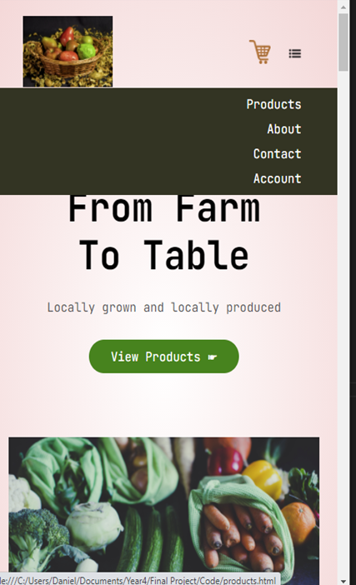

# Appendices

## 3.1 Project Proposal



National College of Ireland

Project Proposal

Farmers Market

An E-Commerce Web Application for trading fresh local products

BSc (Honours) in Computing

Software Development

Academic Year 2020/2021

Student Name: Daniel Costel Neagu

Student Number: x17128463

Student Email: x17124863@student.ncirl.ie

**Contents**

1.0 Objectives 2

2.0 Background 2

3.0 Technical Approach 3

4.0 Special Resources Required 4

5.0 Project Plan 4

6.0 Gantt Chart 5

7.0 Technical Details 6

8.0 Evaluation 7

9.0 References 7

1. Objectives

The most challenging part of this E-commerce Web Application is to make it work successfully, other than the technical implementation and learning of different interconnected systems and technologies from my side, it will be to move the classical approach view of a Farmers Market as a brick and mortar place of commerce and bring it to an Online E-Commerce Platform where the customers and farmers come together and do business.

This E-commerce Web Application is specially built to help the local Farmers and Producers, that are the most affected by these strange times that we all are living in, by providing them with this new Platform, where they can advertise and sale their products.

It will benefit the local community as well, were the local people can purchase again their favourite fresh products as they did once from the Farmers Markets, but this time, safely within reach of a click on the Application and within the Government guidance of respecting Social Distancing Measures.

1. Background

As we are aware of the current Global Pandemic caused by the virus SARS Covid.19 and the effects that it can have on all of us, the Governments of all the Country’s in the World, are trying to reduce the number of people getting sick by this virus.

In Ireland sadly, almost every month the authorities are taking more and more actions on restricting peoples movements In and out of their County, City or even limiting the distance on how far the citizens can travel outside their homes, leaving areas of the city where people used to go and shop at their local Farmers Market unreachable to most of them.

As I looked at my current living situation, I soon realized that by recently moving in a different house, it’s going to be a bit difficult for me now to access some areas of the city that I was fun of them before. The main cause of this matter is the result of new future restrictions to come in the nearest future from the authorities that are put in place to help to stop spreading the Virus Covid_19.

One of these places was my local Farmers Market with my favourite artisan food, cheeses, meats, organic vegetable and fruits. As I wanted to be able to continue to enjoy having them even when the restrictions will restart again to be stricter, I began looking online to see from where I can purchase them from an E-Commerce Website and having them delivered to my new address straight from the Farmers Market. The result of my search revealed that at the moment it is a major gap in the market with the presence of an E-Commerce Farmers Markets Platform, as no Website was available to trade with any products.

By not being able to find any source online from where I can purchase them, I soon realized that this a great opportunity for me to create an E-Commerce Web Application where I can bring together the local Farmers, Producers and Customers. This trade can be extended to other nationwide local Farmers Markets, serving each area in the state and allowing them to trade on my platform.

1. Technical Approach

At first, before I start working on building my application, I must understand how all is going to function in the big picture. One of the very first steps taken in this direction, I will start documenting the requirements specifications for the project. As part of my research in this area of gathering the requirements for my project, I will have to go back on my notes from previous semesters on Business Analysis module and I have to reed over BABOK guide for a quip refresher.

Another step that is taken, it will be by building a Mockup sketch by designing a low fidelity wireframe using the Balsamiq tool for better visualisation of the application that I want to build. In this way, if I noticed anything out of place in the prototype, I can modify the design and find the best solution for the UI.

The actual work of developing the application can start at this stage after gathering the requirements and designing the prototype. All the coding part is going to be done on Visual Studio text editor and all the libraries used for the project are going to install in there.

The deployment will be the next step in my project and for the moment I didn’t decide whom to choose as a hosting services provider.

1. Special Resources Required

One of my special requirements for my project it will be to buy the domain name for Farmers Market.ie and then depending on the packages received on the purchase I will be able to choose the Cloud provider for the application. One of them to consider it will be Heroku, as I must take into consideration the database type that they support on their platform.

1. Project Plan

The Project Plan in Figure 1 from the page below is created by using Microsoft Excel and after watching the recommended YouTube tutorial hosted by Dr Eugene O'Loughlin, Lecturer in Computing at National College of Ireland (2013). The objectives of the project are represented in the Task column with its dedicated duration time for completion, calculate in days. A Status is appointed to each task according to the activity performed on it at the moment.

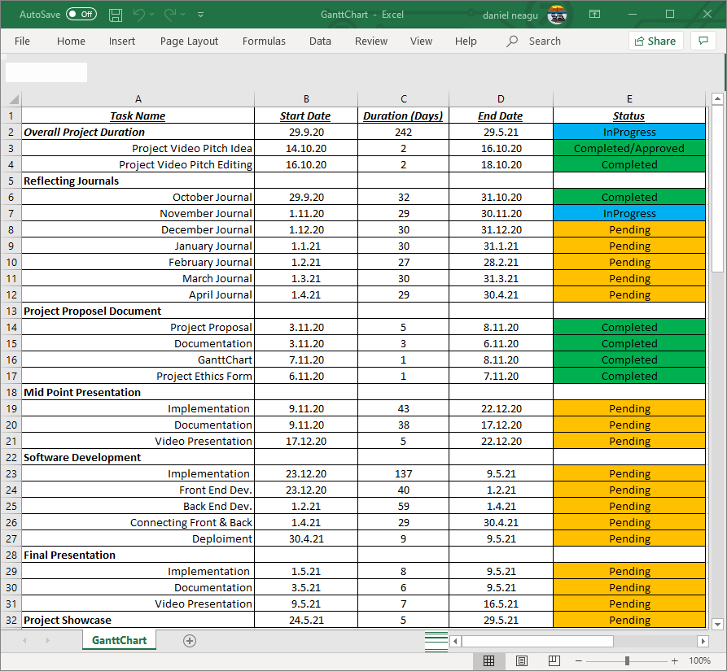

*Figure 1 (Project plan)*

6.0 Gantt Chart

The Gantt chart is incorporating the specific tasks and they are represented on the horizontal bar and the date on the top bar indicating how long the specific tasks are supposed to last.

For a better visual representation of my project timeline, reflecting the project plan is shown below in Figure 2 or you may click on the attached Excel folder here:



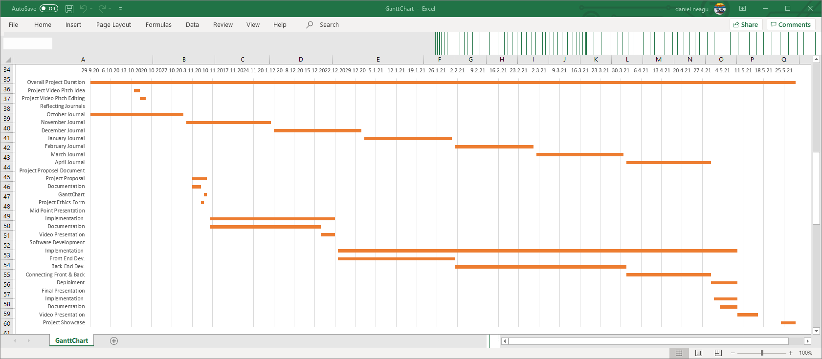

*Figure 2 (Gantt chart)*

7.0 Technical Details

To choose the right tools to build a fully functional E-commerce Web Application and to be deployed successfully is going to be quite some challenge. I am more than sure that some changes to the technologies chosen by me, may occur from the moment I am writing this document up to the finish.

To make it simple for me I will split this project into three deliverable categories. I will implement a well-defined structure with dates to keep Trak of my progression, all these deliverables can be viewed in the Software Development Tasks described in section 5.0 of the Project Plan.

The first part of the project is to build the Front End of the Website, using a common coding language like Hypertext Markup Language (H.T.M.L.) to help me to display the Website that I will design and to be displayed on any web browser chosen by the viewer. Cascading Style Sheets (C.S.S.) to give a little bit of styling on how the web page is going to be displayed on various devices and screens sizes. I will use a scripting language too, like JavaScript (J.S.) and Node.js to help me to add some interactivity to my web site. One of the libraries that I will use in this project is React, it will be used to render dynamic components defined in JSON.

For the second part of this project, I will use Java on the server-side or the back end of the build, is to help me to produce a well define structure. For stock management and any other general-purpose data that needs to be captured and stored I will use a relational database from Azure(Microsoft Azure , 2020), is built for the Cloud and I can use JSON to create and interact with it.

And the third part of the project I will be the connection the front end with the back end of the application and deployment. For these two actions, I have to look for more details later on, because I will be constrained by the Cloud provider and I will have to choose the options available at the time of deployment.

1. Evaluation

Considering the environment and the unfamiliar times that we live in, evaluation of the system has to be done by myself as I didn’t manage to secure any contacts to build this project. I will use mock-up data to populate the necessary field, at a list in this way I will test my database and I will create some fictive profiles for suppliers and customers side, at least in this way I will make a proof of concept that my application is up and running with no problems.

1. References

Microsoft Azure.com (2020) *The database for modern applications* [Online] Available at: https://azure.microsoft.com/en-us/services/sql-database/ [Accessed 4th December 2020]

Eugene O'Loughlin (2013) *How To... Create a Basic Gantt Chart in Excel 2013* [Online] Available at: <https://www.youtube.com/watch?v=QdsjVN3du78>, [Accessed 3 November 2020]